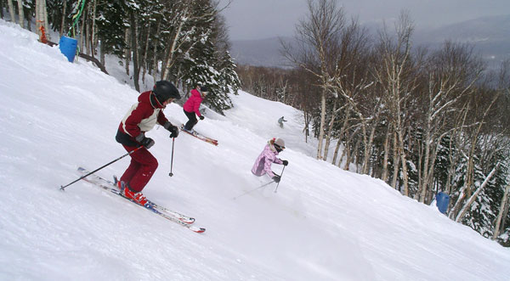

Elk Mountain Ski/Snowboard Trip – open to grades 7 and up!

Sunday, January 28th 2018

Bus will depart from the Peapack Gladstone Municipal Building at 6:15 AM and return at 6:45 PM

Register on-line:
http://www.bedminsterpto.org/index.html

