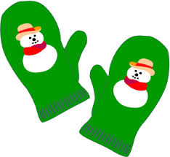
Children’s December events at the Library:

The Elves and the Shoemaker
Live performance by Youth Stages
Saturday 12/9 10:30 am

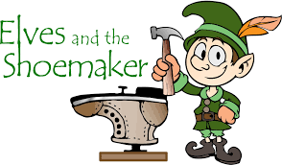

* Holiday Craft

Friday 12/15 4:00 pm
For ages 7 and up

* Space is limited so please call and register: (908) 234-2325 x 107
Children’s Department or e-mail hpetersen@dillonlibrary.org

