SAVE THE DATE!

2nd ANNUAL

BOOKS AND BUDDIES CAFÉ
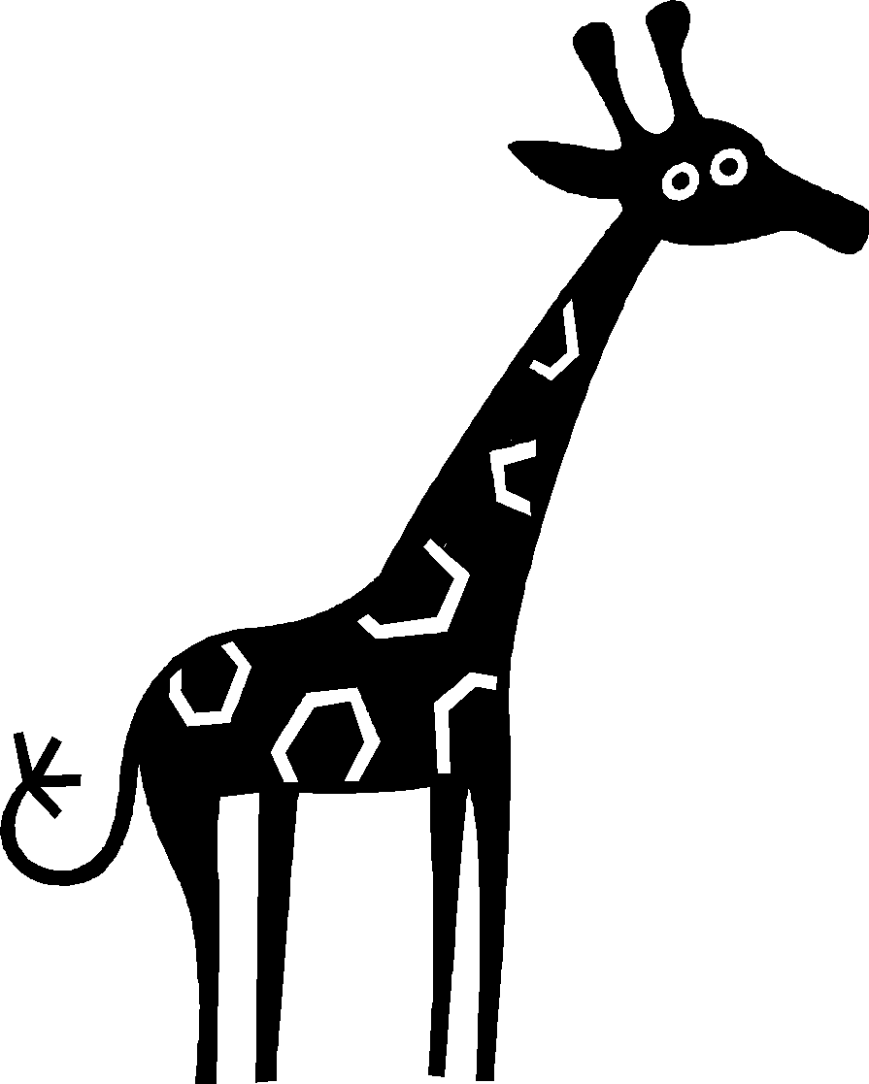

Wednesday, February 7, 2018

6:00 - 7:00 pm ~ Bedminster Cafetorium

A fun-filled evening of reading and sharing!

Choose from a menu of outstanding books with the help of our 4th and 5th grade volunteers!

Open to children in grades preK-3

~ Stuffed Buddy Collection ~

Gently used stuffed animals donations will be collected for Joshua's Closet to support The Cancer Institute of New Jersey

Stay tuned for further details!

