**President’s Welcome**: Ramsey Melendez

* June 11 meeting will include 2019-2020 budget review and vote

**Principal’s Report**: Corby Swan

**Teacher Representative:** Chuck Hogan

**Board of Education Report:** Suzie Stevinson

**Secretary’s Report**: Meghan Schulze

**Treasurer’s Report**: Ralph Wojtech

**New Business**

**2019-2020 Event Chair and Ongoing Committee Chairs: Exec Board**

**Elections 2019-2020 Board Positions:**

The following individuals are seeking re-election for their current Board positions and are running

unopposed. A vote will be cast by a show of hands for each individual candidate.

* Treasurer - Ralph Wojtech
* Secretary - Meghan Schulze
* Vice President - Danielle Fredella
* President - Ramsey Melendez

**Barnes & Noble Book Fair: Monday, June 10, 2019:** [Laura Frantz](mailto:laurafrantz@gmail.com) & Mr. Schoch

* Approx. 15% of all purchases will be available to our teachers to spend on their classrooms
* B&N Bridgewater, Somerville Circle, 5-8 pm
* Volunteers will be needed for short time slots-more info to come
* Summer suggested reading, Father’s Day & graduation items will be available

**Bedminster Police Kickball Tournament: Saturday, June 8, 2019:** [Stephanie Zultanky](mailto:ezpeezylife@gmail.com)

* PTO will be sponsoring a team again this year, sign up [HERE](http://www.rallysocialsports.com/leagues?state=&locationId=&seasonId=81210&days=&levelId=)
* 14 players needed (co-ed)
* Rain date June 15

**Upcoming PTO Meetings:**

|  |
| --- |
| June 11 – 7 pm - Room 315 |

**Old Business**

**Box Tops**: Stephanie Zultanky

* Silly String Contest winning class is ???????

**Spring Fling: Friday, April 26, 2019:** Sandy Ruzicka & Carolyn Richardson

* Thank you!
* $40,000 approximate NET profit
* Please see May newsletter for more detailed information: available [HERE](http://www.bedminsterpto.org/newsletter.html)
* Event recap and handout

**Teacher Appreciation Luncheon: Tuesday, May 7, 2019:** Melissa Kircher & Danielle Fredella

**Ongoing Committees**

**Assemblies**: Angela Gatto, Renee Hachey & Myla Williams

(2019-2020: Angela Gatto, Renee Hachey & Tina Dadas)

**Bedminster Charities Fall Fest: Saturday, October 26:** Tara Mulcahy & Meriah Valente

**Bulldog Monthly:** Executive Board

* <http://www.bedminsterpto.org/newsletter.html>

**Bulletin Boards:** Jodi Coleman & Faith Costabile

(2019-2020: Faith Costabile & Danielle Fredella)

**CIC, The HUB:** Anna Spitaleri

**SH Municipal Alliance:** Anna Spitaleri

* RRW $200 grant

**Cub Scout Pack #1749:** Howard Wolkow

**Donations & Corporate Matching:** Executive Board

* PTO is a 501(c)(3) charity / Tax Id # 223-828-817
* Amazon Smile Program Register [Here](https://smile.amazon.com/gp/f.html?C=NP6V8RZEL291&K=32CLFOQPRJL54&M=urn:rtn:msg:20190220150207d5ab44465f584011a7c298a767a0p0na&R=VODQWPMUUI8R&T=C&U=http%3A%2F%2Fsmile.amazon.com%2Fch%2F22-3828817%3Fref_%3Dpe_732550_393745520&H=XPV9VNJBYCOYLN0CIXB9R974PGQA&ref_=pe_732550_393745520)
* Corporate Matching: check with your company’s HR or Acct Dept.

**Helping Hands**: Linda Fragassi

**Homeroom Parents**: Suzie Stevinson & Jen Calpin

**PR / Social Media:** Ramsey Melendez

* [www.bedminsterpto.org](http://www.bedminsterpto.org) 

**PTO Membership:** Executive Board

**SHEF**: Marisa Austenberg & Ramsey Melendez

**Spirit Wear**: Jessica Pascale & Melissa Kircher

**8Th Grade:** Suzie Stevinson & Tina Costello

[BHS HSA](http://somersethills.ss8.sharpschool.com/parents/home___school_association/b_h_s_h_s_a/h_s_a_meetings_and_events): (Bernards High School Home & School Association)

* + Open invitation from HSA President, [Lisa DiScala](mailto:BHSHSA.Pres@gmail.com)
  + May 21 @ noon, BHS Community room (across the hall from the PAC)

**Closing Notes**: Ramsey Melendez

* Next meeting June 11, @ 7 pm, room 315:
* 2019-2020 budget will be reviewed and vote

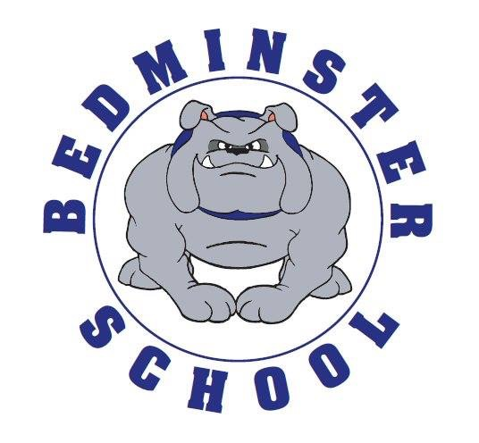

*COMMENTS – We welcome any comments from the floor. However, please direct any questions specifically pertaining to your child(ren) to the appropriate person after the meeting or to the appropriate administrator during school hours. This meeting may be recorded for the sole purpose of writing the minutes.*